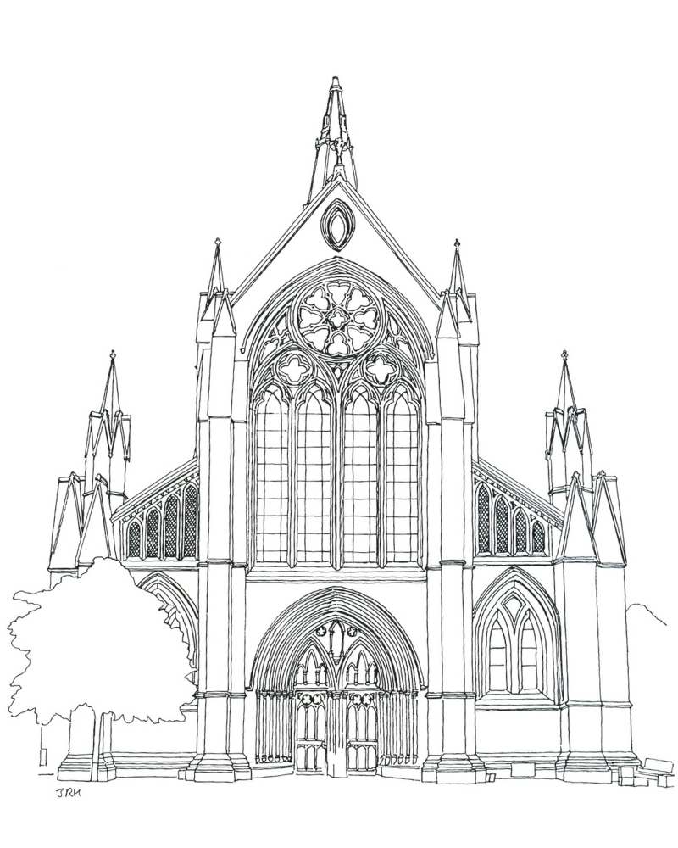
- Bangor
- Bath
- Birmingham
- Blackburn
- Bradford
- Brecon
- Bristol
- Canterbury
- Cardiff, Llandaff
- Carlisle
- Chelmsford
- Chester
- Chichester
- Coventry
- Derby
- Durham
- Ely
- Exeter
- Gloucester
- Guildford
- Hereford
- Leicester
- Lichfield
- Lincoln
- Liverpool
- Manchester
- Newcastle
- Newport
- Norwich
- Oxford
- Peterborough
- Portsmouth
- Ripon
- Rochester
- Salisbury
- Sheffield
- Southwark
- Southwell
- Saint Asaph
- Saint David’s
- Saint Edmundsbury
- Saint Paul’s
- St Albans
- Truro
- Wakefield
- Westminster Abbey
- Winchester
- Worcester
- York

Anglican Cathedrals in England and Wales

