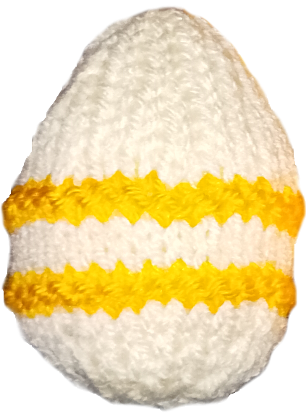
Happy Yeggs!
Knit these cute Yeggs for Easter fun.

Abbreviations
A / B Main colour / contrast colour
K Knit
P Purl
K2tog Knit the next two stitches together
Kfb Knit into the front and back of the next stitch

Using any yarn and needles, cast on 8
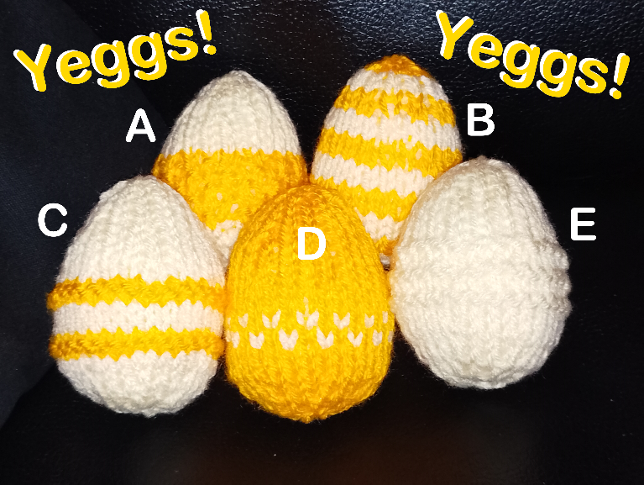
1: P (all odd rows same)
2: Kfb x 8 [16 sts]
4: (Kfb, K1) x 8 [24 sts]
6: (kfb, K2) x 8 [32 sts]
8: K
10: K
12: K
14: (K2tog, K2) x 8 [24 sts]
16: K
18: (K2tog, K1) x 8 [16 sts]
20: K
22: K2tog x 8 [8 sts]
23: P

Cut yarn with 20cm end, thread through remaining 8 sts and draw up.
With right sides together, sew seam nearly to bottom.
Turn right side out, stuff and sew remaining seam.

Variations

A- Moss Stitch Yegg
7: Switch to B, K all round
8: K1, P1 all round
9: P1, K1 all round
repeat 8 & 9 for rows 10-12. Switch to A.

B – Stripy Yegg
Work rows 1 & 2 in A, then 3 & 4 in B, and so on.
Work row 23 in same colour as 22.
Or work in stripes of four rows, or use a different colour for each stripe, or …

C – Double Band Yegg
7: Switch to B, P all round
8: P all round
9: Switch to A, P all round
10: K all round
repeat 7 & 8 for rows 11-12. Switch to A.

D – Speckled Yegg
9: Starting with B, P all round, working sts with alternate colours
10: Starting with B, K all round, working sts with alternate colours
Switch to A
NB, strand unused yarn loosely on wrong side of fabric. Do not pull tight.

E – Garter Stitch Yegg
Purl rows 8 – 12.

What to do with your Yeggs

Yegg-bomb
Get a bunch of people knitting Yeggs (they only take about half an hour to make) and Yegg-bomb your town!
Put a Yegg with its Yegg band in a small bag, perhaps add a mini chocolate egg and a message from your church, then hand them out to random surprised people, or leave them in your local library, surgery, supermarket etc for people to take. (Ask first, of course.)

Bunt-yegg-ing
Get a length of ribbon or yarn (crochet chain looks good) and attach your Yeggs about 6” / 15cm apart for beautiful bunting to celebrate Easter.

Hanging Yeggs
Attach 4” / 10cm narrow ribbon or crochet chain to the top of your Yegg and hang them around the room. Or on your ears - they make great earrings!

Yegg Hunt
Hide a bunch of Yeggs and challenge people to find one of each pattern. Swap a set of Yeggs for a chocolate prize then hide the Yeggs for the next person.

Yegg-lymics
Try the high-throw, long-throw, juggling, relay race, etc with Yeggs. The prize for the winner is to be pelted with Yeggs (and probably chocolate).

Yegg bands
Print off these Yegg bands, decorate, then tape around your Yegg.
Jesus is Alive!
Happy Easter!
New life in Jesus!
Hooray! Jesus is Alive!
Jesus is Alive!
Happy Easter!
New life in Jesus!
Hooray! Jesus is Alive!

